**How to save Microsoft form responses in excel and send an email**

In this blog, we will how to save the Microsoft form responses in the excel from SharePoint and send an email to the admin

1. I have created a sample Microsoft form to work on this task

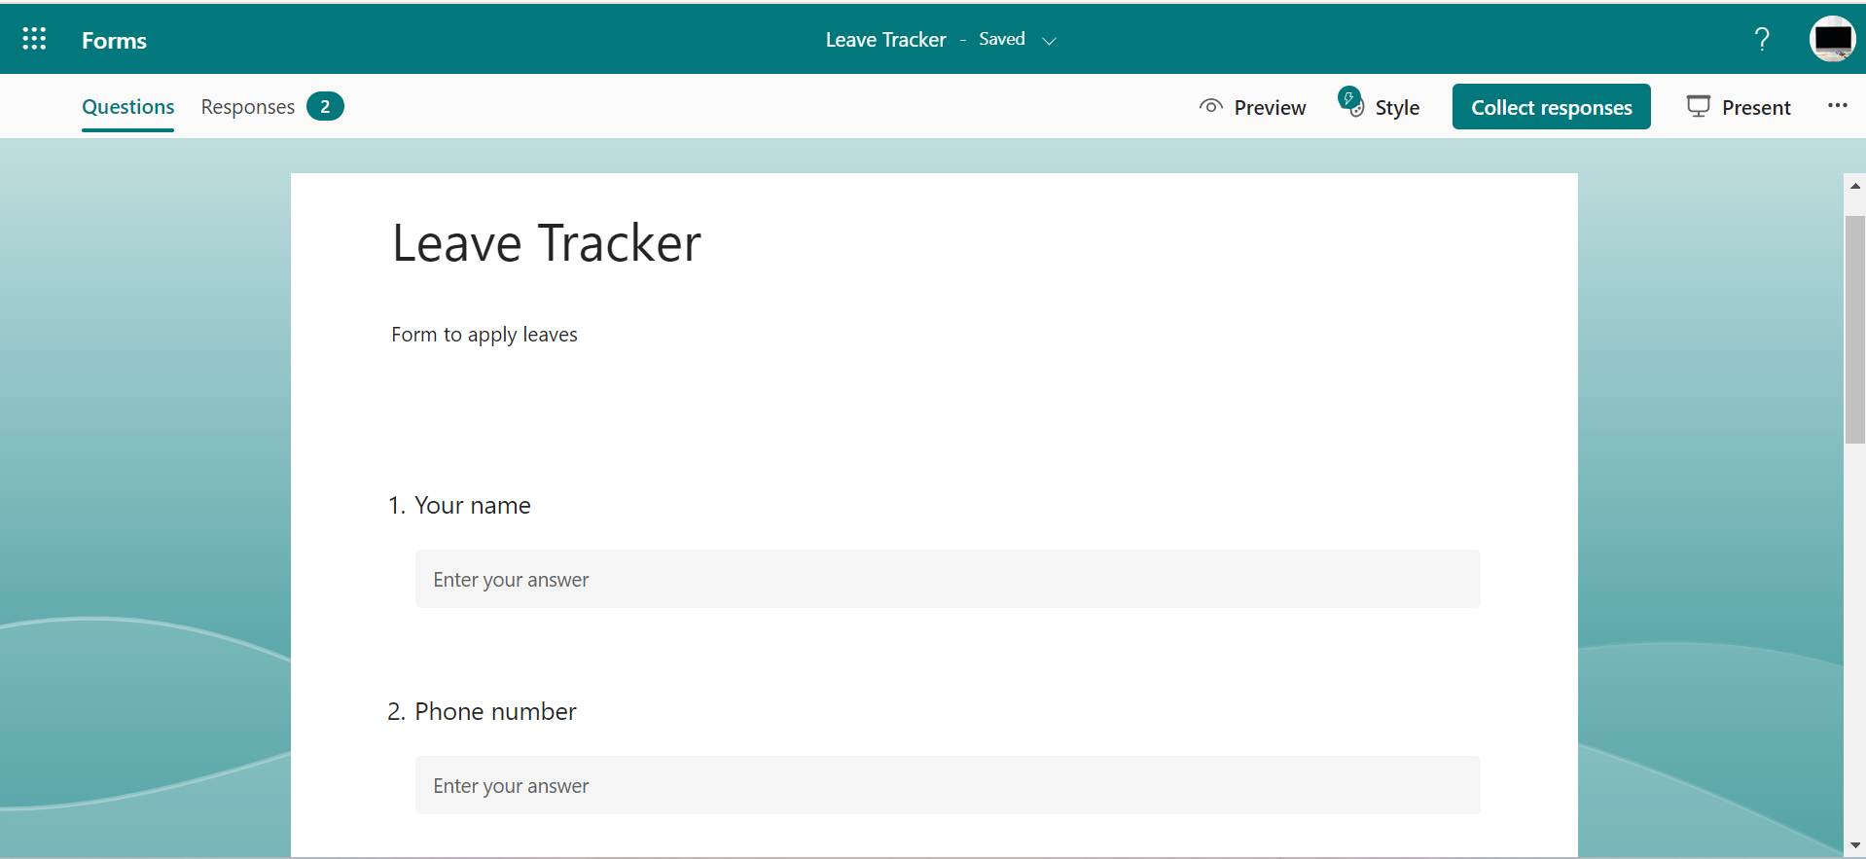

1. Next create an instant flow and take when a new response is submitted from Microsoft forms and next take your form in the form id. 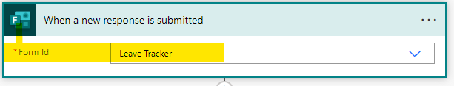
2. Next Add action and take **Get response details** and provide form id and response id

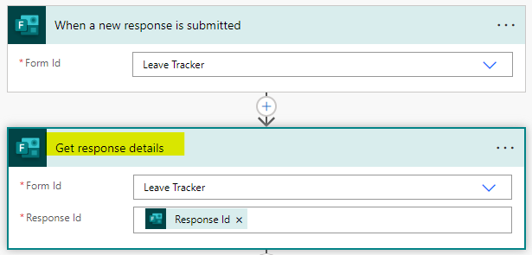

1. Next create an excel file in SharePoint or OneDrive based on your requirement with same fields as headers same like in your Microsoft form

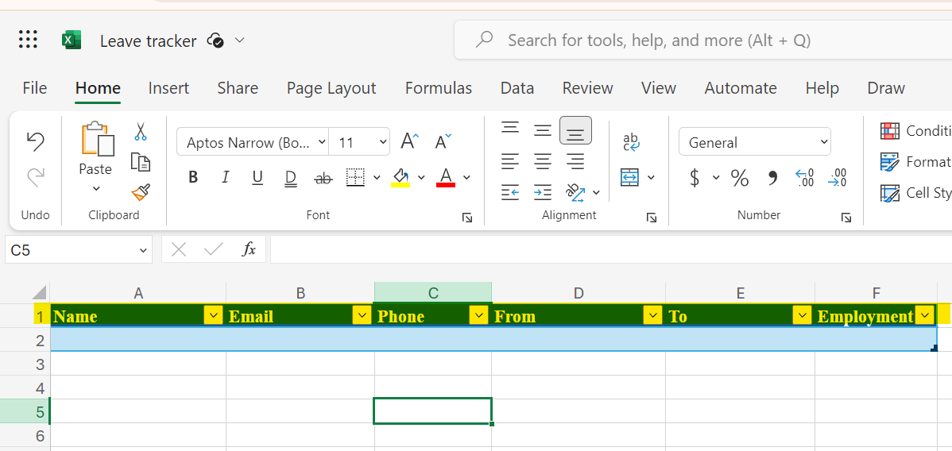

1. Next add an action and take **Add a new row into a table** from excel and map the fields

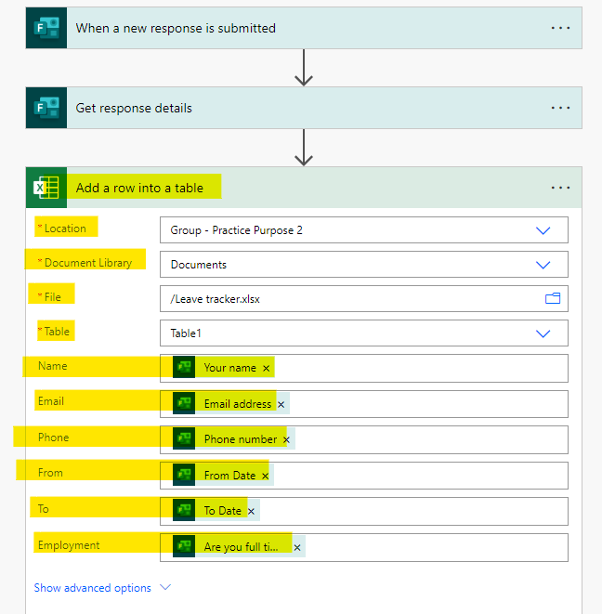

1. Next add another action and add send an email v2 and send the mail whoever you want.

